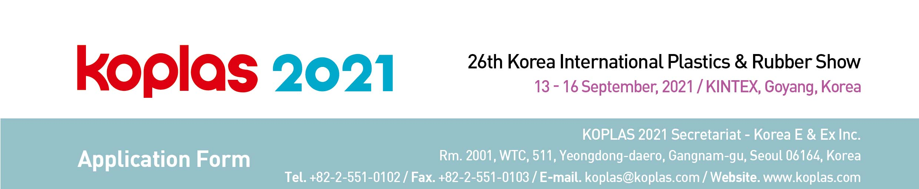

1. Applicant □ Manufacturer □ Importer
Company Name
Company Detail | Address
Company Detail | Country |  | Tel
Company Detail | Website |  | Fax
Contact | Name |  | E-mail
Contact | Dept. |  | Position
Main Exhibits
Korean Agent (if you have) |  |  | Contact
Tel / Fax |  |  | e-mail
2. Type of Booth Space (1 booth: 3 x 3 = 9 sqm)
□ Space Only | USD 2,600 X ________ Booth(s) = USD __________________
□ Shell Scheme | USD 3,400 X ________ Booth(s) = USD __________________
* Special Benefit ① Exhibitors of KOPLAS 2019 will be given a USD 100 discount per 9sqm of space only charge. ② Early Bird Discount – A USD 100 discount per 9sqm is applied to exhibitors who pay the full
amount of booth charge by 17th May, 2021. (More than one discount may be applied.)
* Shell Scheme package includes; fascia board with company name & logo, patrician wall paneling, lighting, carpet, an information desk with a chair, one round table with 4 chairs, and a wastebasket.

3. Payment Options
□ Telegraphic transfer can be made to: Bank: Woori Bank
Branch: Korea World Trade Center
Account No.: 1081-500-336520
SWIFT Code: HVBKKRSE
Account Holder: Korea E & Ex Inc.
Bank Address: 511, Yeongdong-daero, Seoul, Korea
□ Cheques / Bank drafts should be made to: Korea E & Ex Inc.

We hereby apply exhibit space for the KOPLAS 2021. We agree to abide the Conditions and Regulation of Participation states on reverse side of this application form.

Authorized Person _________________________ Title _________________________

Signature _________________________ Date _________________________


